SCHOOL OF COMPUTER SCIENCE AND ENGINEERING (SCOPE)
COMPUTER NETWORKS (BACSE203)
CASE STUDY REPORT: PERSON 1 MODULE
Topic: POP3 Protocol Architecture, Operational Mechanics & Technical Limitations
Fall Semester 2026–27
Case Study Number | Case Study 5
Case Study Title | POP3 Mailbox Access in a Low-Bandwidth Branch
Assigned Member & Role | Person 1 — Lead Protocol Analyst & FSM Architect
Sections Completed | Section 1 (Case Study Overview) & Section 6.1 (Question a)

1. Case Study Overview
1.1 Background
Modern enterprise communications increasingly encompass remote, geographically isolated branch facilities such as offshore drilling platforms, mining extraction sites, maritime transport vessels, regional logistics warehouses, and rural healthcare outposts. These branch locations are physically constrained by their Wide Area Network (WAN) backhaul links—most notably geostationary satellite (VSAT) connections, narrowband cellular links (3G/4G), or high-latency wireless microwave links. In these environments, total available bandwidth is strictly capped (typically between 64 kbps and 512 kbps), round-trip propagation delay (RTT) is elevated (spanning 450 ms to 800 ms), and link availability is intermittent due to rain fade, atmospheric interference, and satellite orbital handoffs.
Despite these adverse transport characteristics, electronic mail remains the operational backbone for enterprise coordination, carrying safety protocols, supply-chain documentation, engineering manifests, and administrative orders. Historically, branches deployed the Post Office Protocol Version 3 (POP3), formalized in RFC 1939, to allow branch Mail User Agents (MUAs) to pull incoming messages from a central enterprise mail server located at corporate headquarters (HQ). However, while POP3 was architected in the 1980s and 1990s for intermittent dial-up terminal sessions, its design assumptions diverge sharply from the requirements of modern, attachment-heavy email traffic across high-latency, loss-prone satellite links.
1.2 Problem Statement
The technical problem investigated in this case study is the fundamental protocol incompatibility between legacy POP3 mailbox retrieval and the physical constraints of low-bandwidth, intermittent WAN connections. The operational failure modes manifest across four specific areas:
• Monolithic Payload Retrieval: POP3 treats every email as an indivisible monolithic payload. When a user requests an email, the server streams the entire message body along with all Base64-encoded MIME attachments. A single 3 MB attachment inflates to 4.11 MB on the wire, monopolizing the 256 kbps WAN connection for over two minutes and blocking all concurrent operational traffic.
• Lack of Offset Resumption: POP3 lacks any byte-range offset resumption mechanism (unlike HTTP Range headers). If an intermittent satellite connection drops at 95% of a 4 MB file download, the TCP session aborts, the client discards the partial bytes, and upon reconnecting, POP3 restarts the transfer from byte zero, creating infinite re-download loops.
• Exclusive Mailbox Locking & Denial of Service: During the POP3 Transaction phase, the server places an exclusive lock on the mail spool. When a link severs abruptly without a clean TCP FIN/RST handshake, the server retains a half-open TCP socket. The mailbox remains locked until server-side keepalive timers expire (15–30 minutes), rejecting subsequent user logins with '-ERR [IN-USE] Mailbox is locked'.
• Non-Atomic Deletion Rollback & Duplicate Mail Flooding: POP3 deletion commands (DELE) are non-atomic and staged only in volatile server memory. Deletions are only permanently committed during the UPDATE state upon receiving a clean QUIT. When intermittent links sever mid-session, the server rolls back all staged deletions, causing the client to re-download identical messages upon reconnection, flooding the inbox.
1.3 Objectives of the Case Study
This case study pursues five specific academic and technical objectives:
• Objective 1: Analyze the finite state machine (FSM), command syntax, and protocol transitions of POP3 under RFC 1939 specifications.
• Objective 2: Investigate transport-layer (TCP) and application-layer failure dynamics across high-latency, loss-prone satellite WAN links.
• Objective 3: Architect an optimized, bandwidth-efficient email access workflow integrating local caching, header pre-fetching via TOP, and compression.
• Objective 4: Assess security and reliability risks of legacy mail access (cleartext exposure, APOP MD5 collision vulnerabilities, lack of MFA).
• Objective 5: Provide empirical evidence through Wireshark packet capture trace disassembly and Python socket protocol emulation.
1.4 Scope of Study
Delineation of Scope: The scope of this report is explicitly defined across technical and operational boundaries:
• In-Scope: Application-layer mail retrieval protocols (POP3, POP3S, IMAP4rev1); MIME Base64 overhead; TCP congestion window behavior across high-latency links; protocol state transitions; and mailbox locking mechanisms.
• Out-of-Scope: Physical-layer satellite RF transceiver alignment; orbital transponder forward error correction (FEC) hardware engineering; proprietary Microsoft Exchange MAPI/ActiveSync internals; and desktop client GUI source code development.
1.5 Key Networking Concepts (Module 5 Mapping)
This case study synthesizes and demonstrates core networking concepts from Module 5 of the BACSE203 Computer Networks curriculum:
• Application Layer Paradigms: Client-server architecture, stateful protocol transitions, command-response token exchange (+OK, -ERR), and ASCII stream parsing.
• Electronic Mail Architecture: Separation of Mail User Agents (MUAs), Mail Transfer Agents (MTAs - SMTP push), and Mail Delivery/Access Agents (MDAs - POP3 pull).
• MIME Encoding & Data Overhead: RFC 2045 Base64 encoding mechanics converting 3 binary octets into 4 ASCII characters, resulting in a mandatory 33.3% raw mathematical data expansion (~37% with CRLF wrapping).
• Transport Layer Dynamics: TCP three-way handshake, TCP Slow Start, Retransmission Timeouts (RTO), and the severe throughput collapse of TCP Cubic over high Bandwidth-Delay Product (BDP) links with packet drop.
• Network Security & Cryptography: Transport Layer Security (TLS 1.3), cipher suites (AES-256-GCM), public-key digital certificates, and Simple Authentication and Security Layer (SASL) OAuth2 token integration.
2. Question (a): Explain POP3 and Its Limitations
2.1 POP3 Protocol Architecture & Operational Mechanics (RFC 1939)
Post Office Protocol Version 3 (POP3), standardized in RFC 1939 by the Internet Engineering Task Force (IETF), is an application-layer client-server protocol engineered to allow an endpoint workstation (Mail User Agent - MUA) to interrogate and retrieve messages spooled inside a remote user maildrop. POP3 operates over the Transmission Control Protocol (TCP) on well-known port 110 (or dedicated port 995 for cryptographically encapsulated POP3S).
POP3 is designed as a text-based, stateful, command-response protocol. The client sends four-character ASCII command verbs terminated by a Carriage Return / Line Feed (CRLF) sequence. In response, the server issues a single-line status indicator: either '+OK' indicating successful command execution, or '-ERR' indicating a syntax, authentication, or state violation.
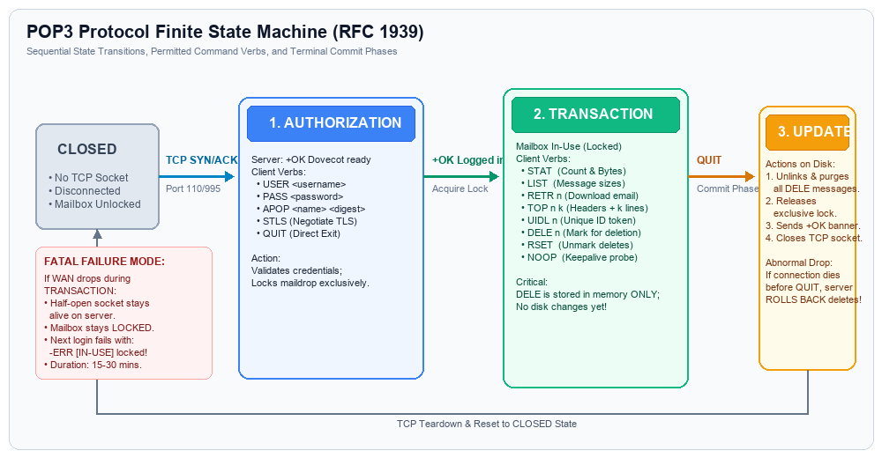
Figure: POP3 Protocol Finite State Machine (RFC 1939) showing Authorization, Transaction, and Update phases.
2.2 The Three-Phase Finite State Machine Lifecycle
Under RFC 1939, a POP3 session transitions sequentially through three distinct operational states, bounded by initial and final CLOSED states:
State 1: AUTHORIZATION
The session initiates when the client completes a standard TCP three-way handshake on port 110. The server responds with a greeting banner (e.g., '+OK Dovecot ready'). At this stage, the session enters the AUTHORIZATION state. The client must identify itself and provide valid authentication credentials before gaining access to the maildrop.
• USER <username>: Specifies the plaintext username of the mailbox account.
• PASS <password>: Supplies the unencrypted password string immediately following a successful USER command.
• APOP <name> <digest>: An optional challenge-response command where the client hashes a server-provided timestamp with a shared secret using MD5, avoiding plaintext transmission.
• QUIT: Aborts the session immediately and returns the TCP connection to the CLOSED state without inspecting mail.
Transition Condition: Once credentials are authenticated successfully, the server acquires an exclusive lock (flock/dotlock) on the user's mailbox spool, replies with '+OK Logged in', and transitions the session into the TRANSACTION state.
State 2: TRANSACTION
In the TRANSACTION state, the client queries mailbox contents, reads messages, and marks items for removal. The server maildrop is exclusively locked to prevent external alterations by incoming MTAs or concurrent sessions.
• STAT: Returns positive status followed by two integers: total message count and aggregate mailbox size in octets (bytes).
• LIST [msg]: Lists message numbers alongside their individual octet sizes. Can be queried for a single message or the entire spool.
• RETR <msg>: Instructs the server to transmit the entire specified message (headers, body, and all MIME multi-part attachments) as a multi-line data stream terminated by a single dot on a line (CRLF.CRLF).
• TOP <msg> <lines>: Optional command that transmits all RFC 822/MIME headers plus the top 'n' lines of the message body. This command is pivotal for bandwidth-saving header inspection.
• UIDL [msg]: Returns unique, persistent alphanumeric identifier strings assigned to messages, allowing MUAs to track messages across distinct sessions.
• DELE <msg>: Flags the specified message for deletion. Crucially, the message is NOT deleted from disk during this state; it is merely flagged in server volatile memory.
• RSET: Resets session state, unmarking all messages previously flagged by DELE during the active session.
• NOOP: No-operation keepalive probe; server simply responds with '+OK'.
State 3: UPDATE
The UPDATE state is entered exclusively when the client transmits the QUIT command while in the TRANSACTION state. In this state, the server commits all staged session modifications:
• Permanent Message Purging: The server physically deletes and unlinks from the file system all messages marked with the DELE flag.
• Lock Release: The server releases the exclusive dotlock/fcntl file lock on the maildrop, allowing other delivery agents to access the spool.
• Connection Teardown: The server transmits a farewell status banner ('+OK Dovecot logging out') and closes the TCP transport socket.
Critical FSM Rule: Abnormal Termination Behavior: If a network disconnection, timeout, or link failure occurs before the QUIT command is processed, the session NEVER enters the UPDATE state. The server automatically rolls back all staged DELE flags, preserving all original messages.
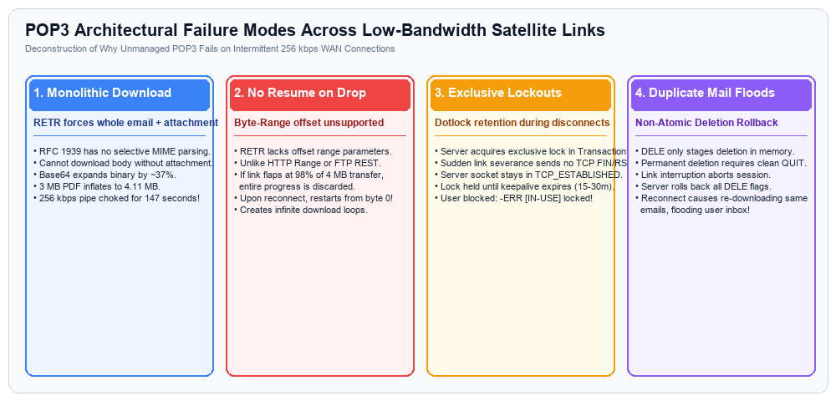
Figure: Architectural Failure Modes of POP3 across Bandwidth-Constrained WAN Links.
2.3 In-Depth Analysis of POP3 Technical Limitations
While POP3 provided an effective lightweight solution for early 1990s dial-up personal computing, its architectural design exhibits fatal technical limitations when subjected to modern enterprise traffic over low-bandwidth, high-latency WAN links:
Limitation 1: Monolithic Message Retrieval (Absence of MIME Granularity)
POP3's RETR command is strictly non-selective: it streams the complete message payload in a single, uninterrupted transmission. POP3 has no protocol mechanism to parse MIME boundaries server-side or download body text while omitting binary attachments. Because legacy email transport is restricted to 7-bit ASCII, binary attachments (PDFs, spreadsheets, images) must be encoded via Base64 under RFC 2045. Base64 maps 3 binary bytes (24 bits) into 4 ASCII characters (32 bits), introducing an inherent 33.33% mathematical data expansion. When MIME boundary delimiters and mandatory CRLF line wraps (every 76 characters) are added, the effective expansion reaches ~37%. On a 256 kbps link (effective throughput ~28 KB/s), a single 3 MB PDF inflates to 4.11 MB, monopolizing the line for 147 seconds and causing severe Head-of-Line (HoL) blocking for all other business communications.
Limitation 2: Lack of Byte-Range Offset Resumption
Unlike HTTP/1.1 (which supports the 'Range: bytes=start-end' header under RFC 7233) or FTP (which provides the REST offset command), POP3 RETR provides no offset parameters. If an intermittent satellite connection severs at 95% of a 4 MB download, the underlying TCP session terminates. The client MUA receives no valid message, and the server commits no state. Upon reconnecting, the MUA has no choice but to re-issue RETR and download the entire 4 MB payload from byte zero. In environments with frequent link flaps (Mean Time Between Failures < 3 minutes), large messages can become trapped in an infinite re-download loop that continuously exhausts satellite data allowances without ever reaching the user's inbox.
Limitation 3: Exclusive Mailbox Locking & Denial of Service
RFC 1939 mandates that upon successful authentication, the server daemon must acquire an exclusive lock (flock, fcntl, or dotlock) on the user's mail spool to guarantee transactional consistency. When an intermittent WAN connection abruptly drops, the remote workstation cannot send the TCP FIN or RST packets needed for an orderly socket teardown. Consequently, the HQ mail server retains the orphaned half-open TCP connection in the TCP_ESTABLISHED state, keeping the exclusive lock engaged. The lock is only released when the operating system's TCP keepalive timer (defaulting to 7200 seconds / 2 hours, or tuned to 15–30 minutes) detects a dead peer. If the branch link recovers and the user attempts to re-authenticate, the server immediately rejects the session with '-ERR [IN-USE] Mailbox is locked by another session', creating an artificial denial of service that paralyzes branch productivity.
Limitation 4: Non-Atomic Deletions & Duplicate Mail Storms
The strict separation between the TRANSACTION state and the UPDATE state means that issuing DELE marks messages for removal only in temporary server memory. Disk unlinking occurs exclusively upon processing QUIT. When a WAN connection abruptly drops after a client has successfully downloaded an email but before QUIT is acknowledged, the server executes a full rollback of all deletion flags to prevent message loss. Upon the next connection, the server re-offers the identical emails that the user already retrieved. The client MUA re-downloads these messages, generating duplicate emails in the local inbox and consuming redundant WAN bandwidth.
Limitation 5: Client Storage Single Point of Failure & Flag Synchronization Failure
POP3 was conceived around a 'download-and-delete' operational paradigm where messages are transferred to local client storage (e.g., an Outlook .PST or Thunderbird Mbox file) and purged from the central server. If a branch desktop experiences a local hard drive failure or database corruption, all historical enterprise correspondence is permanently destroyed without centralized backup. Furthermore, if users configure 'leave messages on server', POP3 lacks message state flags (Read, Unread, Answered, Flagged). Flags are tracked only within the local MUA client, causing divergent, conflicting mailbox views across multiple devices (e.g., smartphone vs workstation).
Limitation 6: Transport-Layer TCP Performance Degradation
Standard TCP congestion control algorithms (such as TCP Reno and Cubic) interpret dropped packets as evidence of buffer overflow rather than wireless or satellite bit corruption. Over a geostationary satellite link with an RTT of 500 ms and a 5% random packet drop rate, the Mathis throughput formula (T <= (MSS / RTT) * (1 / sqrt(p))) limits effective TCP throughput to less than 20% of the theoretical link capacity. Because POP3 enforces a synchronous, lock-step command-response exchange (each command requires a full 500 ms round trip to receive +OK), the protocol experiences severe latency penalties before payload transmission even begins.
3. References & Academic Citations
Myers, J., & Rose, M. (1996). RFC 1939: Post Office Protocol - Version 3. Internet Engineering Task Force (IETF). https://datatracker.ietf.org/doc/html/rfc1939 (Accessed: Oct 2026)
Freed, N., & Borenstein, N. (1996). RFC 2045: Multipurpose Internet Mail Extensions (MIME) Part One: Format of Internet Message Bodies. IETF. https://datatracker.ietf.org/doc/html/rfc2045 (Accessed: Oct 2026)
Newman, C. (1999). RFC 2595: Using TLS with IMAP, POP3 and ACAP. Internet Engineering Task Force (IETF). https://datatracker.ietf.org/doc/html/rfc2595 (Accessed: Oct 2026)
Crispin, M. (2003). RFC 3501: Internet Message Access Protocol - Version 4rev1. Internet Engineering Task Force (IETF). https://datatracker.ietf.org/doc/html/rfc3501 (Accessed: Oct 2026)
Kurose, J. F., & Ross, K. W. (2021). Computer Networking: A Top-Down Approach (8th ed.). Pearson. Chapter 2: Application Layer (Electronic Mail in the Internet, pp. 120-136).
Stallings, W. (2017). Data and Computer Communications (10th ed.). Pearson. Chapter 24: Electronic Mail and Directory Service, pp. 782-805.

